**CP2406 Programming 3 Assignment 1**

*By: Matthew Cabinian*

**Problem Specification:**

The problem provided was to design and create a functioning car traffic simulator designed to at least use Cars, Motorbikes and Buses. The program must showcase the road with working traffic lights along with the various vehicles moving along the road and pass through. Not only that but must also allow timing duration for each of the traffic lights to work and allow cars to move through the intersection segments within the simulated road.

**Problem Decomposition:**

As there are various objects needed to run for the simulation to fully function, the objects are divided into the following:

* Road:

As the road needs to be able to track the various vehicle objects and have the traffic lights stationed at different segments of the road. To accomplish this, the road will be separated into 2 car lanes both either going east or west and have intersections going north and south along with traffic lights associated to each intersection added.

* Road ID

The ID used to help identify whether the road orientation is horizontal or vertical

* Intersection ID

This intersection ID is to allow the program to indicate where and when to stop and to provide an area where the traffic lights could be added into the road segment and allow the user to add more or less within the simulation

* Start Location

The roads have a starting location within the segments to allow flow of traffic to begin and to also simulate the

* End Location

Each road must have a designated end point to allow more “NPC” vehicles to be part of the simulation

* Directions (East, West, South, North)

This is used to help orientate the vehicles within the simulation on the directions it is supposed to take as well as the flow of traffic simulating the Australian traffic laws.

* Vehicle:

Vehicle class had 3 different subclasses to allow variety and distinction when the simulator is being used

* Car:

1. Speed:

Determined by the user input, it will allow the simulation to run the designed speed limit or increased or decreased speed when the simulated car moves through the road or other segments implemented

1. Length:

As the default vehicle to test, the Car object has a default length of 2 units to provide a simulated

1. Wheels:

Using the wheels as a point to help illustrate the cars movement with and without an image. With the default setting of 4 sets of wheels for the Car

1. Movement (East, West, North, South):

To give direction for each vehicle within the simulation and to give proper alignment wherever the vehicle starts at along with any other “NPC” vehicle stationed within the simulated road

* Bus:

Same variation as Car but the length is about 3 or 4 units and has around 4-6

* Motorbike:

Same variation as Car but has 2 wheels, 1 unit shorter and ½ width than the car

* Traffic Lights:
* Color Change:

As to ensure the somewhat realistic aspect of the simulation, the traffic lights must be able to change from Red to yellow and green, simulating the real-life traffic light system

* Duration:

The timer used to allow the different vehicles in intersections to move through and prevent the simulation vehicles from crashing into one another and obey the simulated traffic laws

**UML Class Diagram**

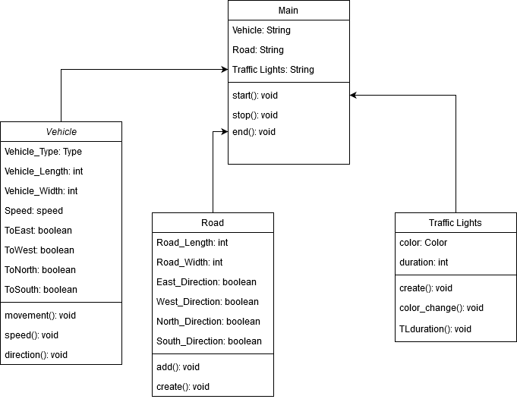

**User Stories**

1. Person 1:

|  |  |
| --- | --- |
| Name: | Adrien Agreste |
| Age: | 18 |
| Purpose: | The user has approached our team and said that while he is willing to purchase a car for his 18th birthday, his father is not willing to allow his son to test cars until he finalizes his decision on which car to purchase. |
| Priority Level: | High |
| Test: | The user will describe the vehicle specifications for the simulation to determine how fast, how far, how big and how it is able to perform on the road simulation. |

1. Person 2:

|  |  |
| --- | --- |
| Name: | Ryan Sterling |
| Age: | 34 |
| Purpose: | The user has asked our team for assistance. As the head of a car production company, he asks that our team for a program that can determine the speed of vehicle of his choosing when these specific vehicles are on the road |
| Priority Level: | Medium |
| Test: | When the user asks for a specific speed for a vehicle, the program will showcase the speed for the vehicle and demonstrate the speed in the car simulator |

1. Person 3:

|  |  |
| --- | --- |
| Name: | Christina Everlore |
| Age: | 25 |
| Purpose: | This user approached our team with the issue related to the algorithm of traffic algorithms. She was tasked with overseeing construction of a newly built road and needed guidance for how long the traffic system turns red to green, vice versa. |
| Priority Level: | Medium |
| Test: | When using the simulation, check the duration of the traffic lights from switching depending on the lane, no. of cars, etc. |

1. Person 4:

|  |  |
| --- | --- |
| Name: | Marinette Dupain |
| Age: | 30 |
| Purpose: | The user asked our team for assistance as she is currently a recently appointed driving instructor but from another country and will move to Australia for her occupation. She requested to understand the traffic flow and direction of the traffic in Australia to be able to adapt and learn and readjust her teaching methods when she relocated to Australia |
| Priority Level: | Low |
| Test: | The simulation must have at least showcased the direction for the road and where the vehicle goes when moving along the road. |

Git hub repository:

<https://github.com/Matthewcabinian144/CP2406-Assignment-1>